**19/07/2019, 12:00**

AI Digital Marketing

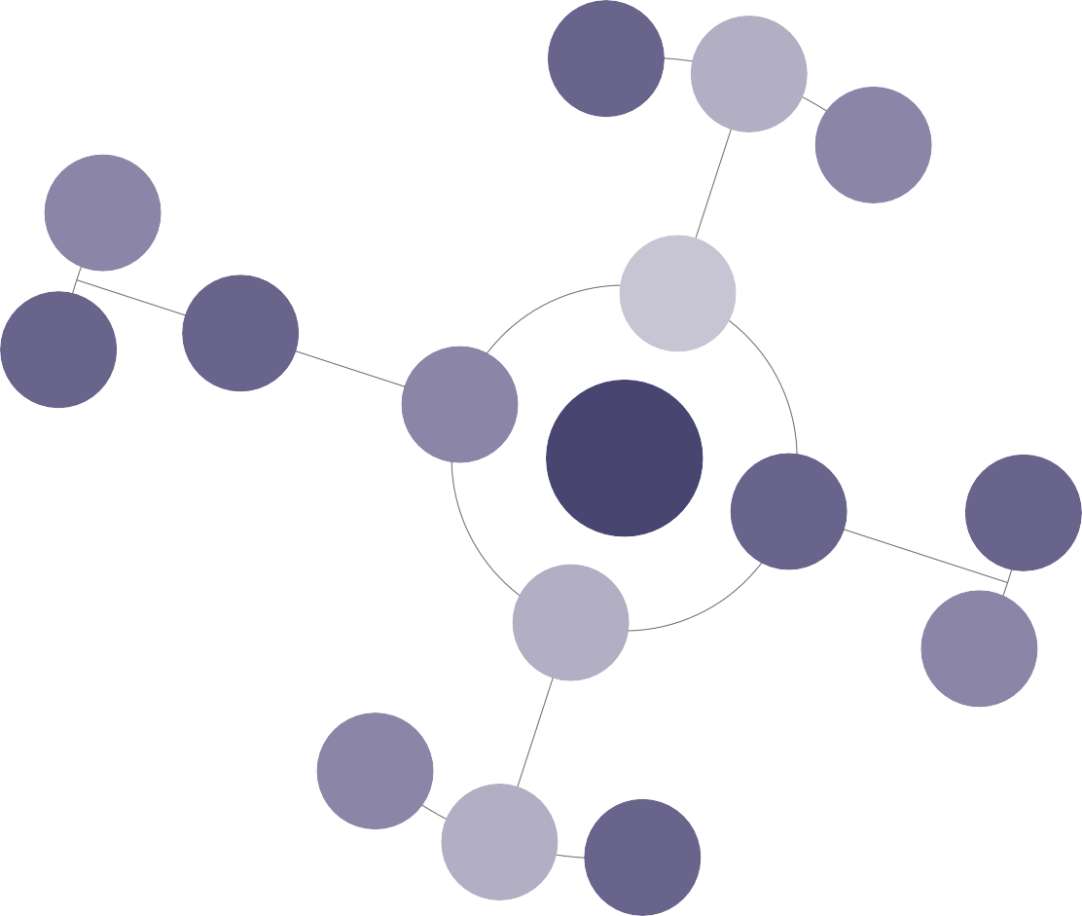

80% of

businesses want a chatbot in the next few years

Chatbots can

be self hosted or work through apps like Facebook Messenger

Chatbots can

be used for customer service, taking orders, and even increasing

Machine

learning allows computers to recognise patterns in huge data sets to

Chatbots

Predictive

analytics is the use of data to predict future outcomes and behaviours. Can

The more data

we collect about users, the more we can target ads to them

Big Data

AI Digital

Marketing

Programmatic

Advertising

Shows ads

based on stats on a range of different platforms

Conversational

Search

Evolves with

time to become more efficient

Use LSI

Use questions

Google is an AI

first company